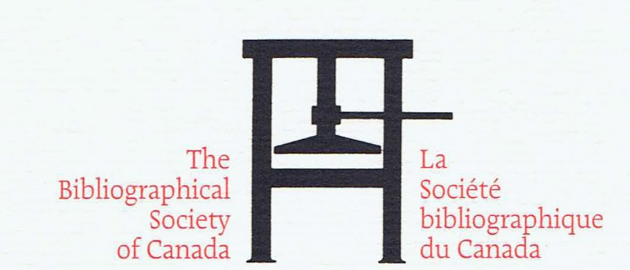

Widening the Circles: The role of texts

On June 3rd and June 4th, 2019 bibliographers and book historians will gather at the Congress of the Humanities and Social Sciences in Vancouver, British Columbia to explore how text in all its forms has and is conveying the conversations of Canadians, how books have inspired conversations, and how the role and form of the book is evolving as text appears in new mediums and online readers interact with text in different ways.

To explore these themes, proposals for papers and panels are requested in the following subject areas:

- the decolonization of bibliographical research to redress gaps in representation, approach and/or genre;
- the histories of texts/books/print objects as they are re-circulated through republishing/digitalization projects in public institutions;
- the development and impact of reading clubs, public and private book discussion groups, book blogs, online reviews and literary awards in shaping reading tastes and expectations;
- the role played by Canadian small presses and campus literary journals in giving voice to previously unheard voices and as a learning venue for future writers and publishers;
- explorations of the role of the translator and/or cultural historian in making texts accessible to wider audiences;
- the impact of the rare book marketplace on the creation of literary archives;
- investigations of the role that book design and production play in the book’s meaning, potential market and reader satisfaction; and
- the interplay evolving between analog and digital publishing.

In recognition of our gathering in Vancouver, proposals that address aspects of the history, literature and book culture of British Columbia are particularly encouraged.

Please submit a one page proposal and brief biography in English or in French ( including your full name, professional designation, institutional affiliation or place) no later than 30 November 2018 to: proposals@bsc-sbc.ca.

